Team Member Application
Full Name:
Address:
Phone:
Email:
Time of Day
Available:
Comments:
Referred By:
Wed Thu Fri Sat Sun
Tues
Mon
First
Last
Date:
Street Address
City
State
Zip Code
)
Home
(
)
Cell
(
indicate rance per day
(
)
High School:
Cummulative
GPA
Year Graduated or
Est. Graduation
Year Graduated or
Est. Graduation
Cummulative
GPA
College:
Sports & Extracurricular Activities:
Current students, please turn in application with a copy of your most recent school report card.
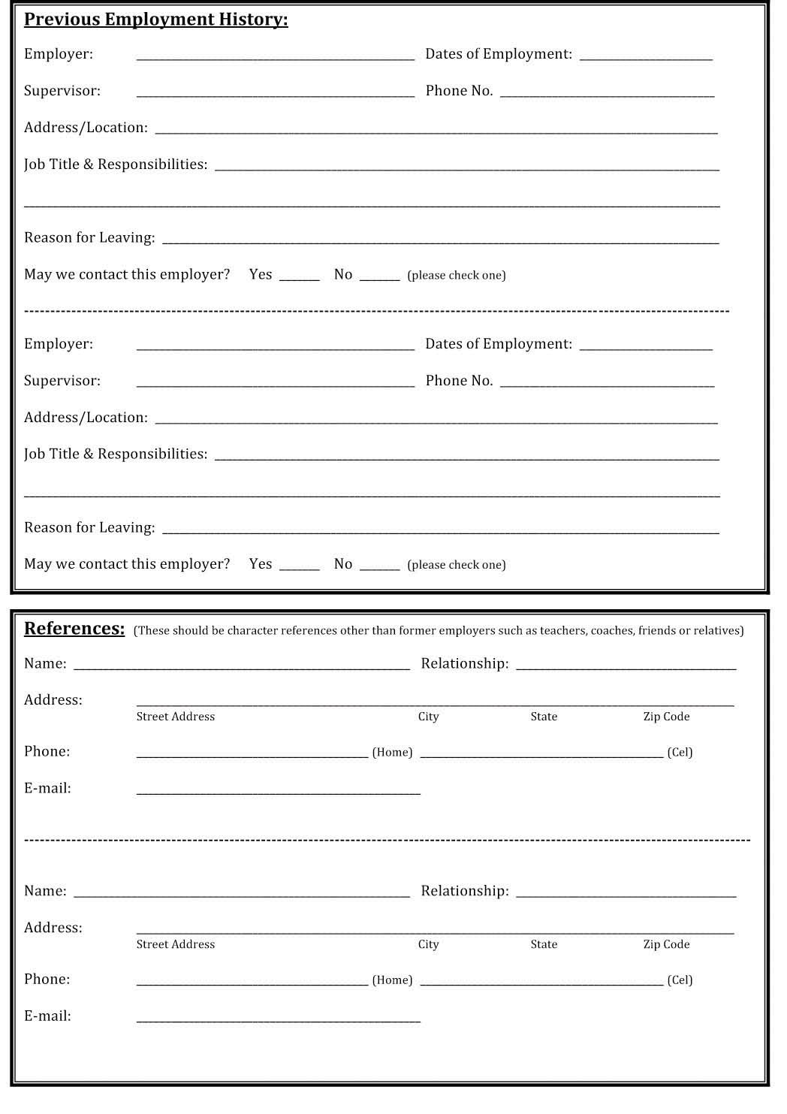

Notification, Authorization and Certification:
I am hereby notified that certain diseases such as Hepatitis A, E Coli 0157, Salmonella, Shigella, Staphylococcus, Giardia, Streptococcus and Campylobacter will prevent me from handling food equipment until a clean bill of health is received from my medical doctor. It is my obligation to Pelican’s SnoBalls to immediately notify my supervisor should I knowingly become or believe that I am infected with any of these diseases.

I hereby authorize the former employers and references I have listed on this application to provide to Pelican’s SnoBalls with any information that would be meaningful and relevant to this employment application and I release all parties from all liabilities and/or damages that result from furnishing such information. I certify that I have fully read and have accurately completed this employment application to the best of my knowledge. I acknowledge that any false information contained in this employment application may be grounds for Pelican’s SnoBalls to disregard my employment application or to terminate my employment upon discovery of such false information.

I agree to read and follow the rules and regulations contained in the Pelican’s SnoBalls Employees Handbook that will be provided to me upon my employment and which may be updated
periodically by Pelican’s SnoBalls. I understand that Pelican’s SnoBalls is an at-will employer and that Pelican’s SnoBalls may terminate my employment at any time for any reason, with or without cause and that I also have these same rights with regard to terminating my own employment.

I understand that Pelican’s SnoBalls is an equal opportunity employer and that Pelican’s SnoBalls makes every effort to comply with various federal, state and local employment laws, as applicable. I also understand that the information I have provided in this application will not be used for any purposes(s) that are prohibited by law.

Signature_______________________________________ Date___________________

*Email completed application to dbsbenterprisellc@gmail.com

